HPX
Hai Phat Invest
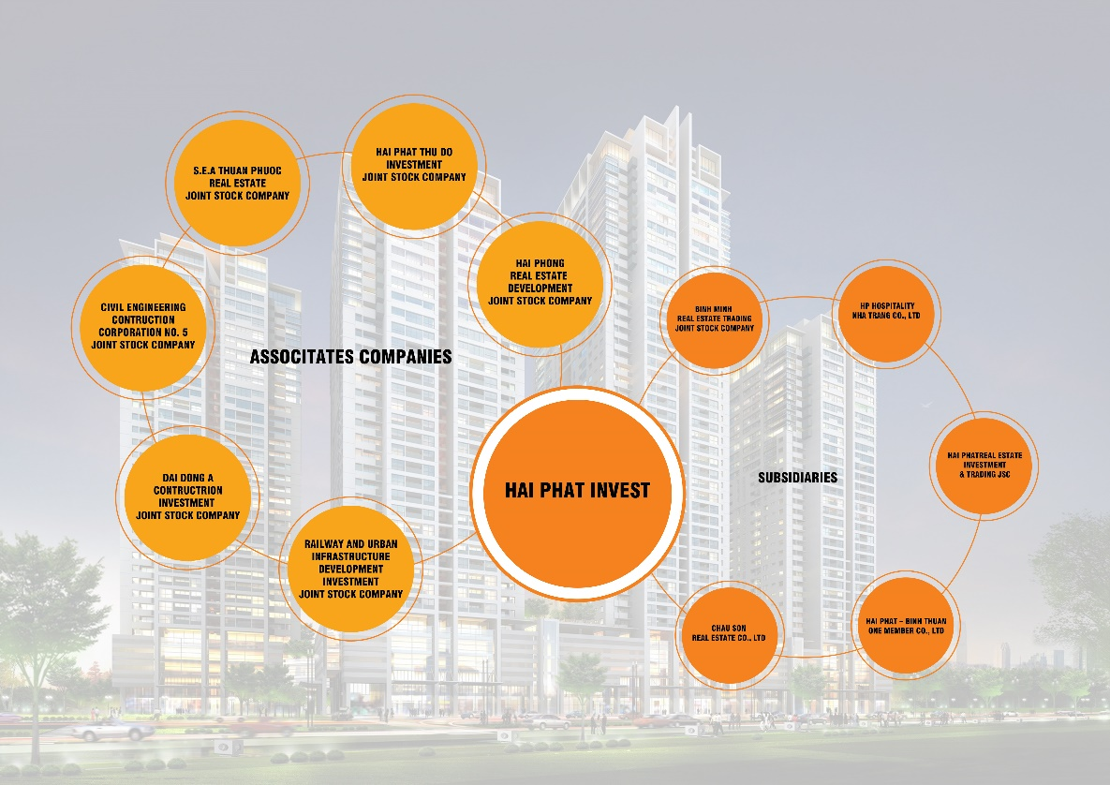
12/2018 | INVESTOR NEWS

Stock informations  28/12/2018 UNIT HPX  Price ‘000 VND 26  Market Capitalization Billion VND 5,199.90  Oustanding Shares Million stocks 199.99  Foreign ownership rate/limit of foreign ownership rate % 15.26/49  Highest/Lowest price in 52 weeks ‘000 VND 26.10/ 20.17  Average trading volume since IPO shares 464,808  Average trading value Million USD 0.53  EPS TTM VND 2,262  P/E TTM Times 11.05  P/B Times 1.97  Proportion of ownership  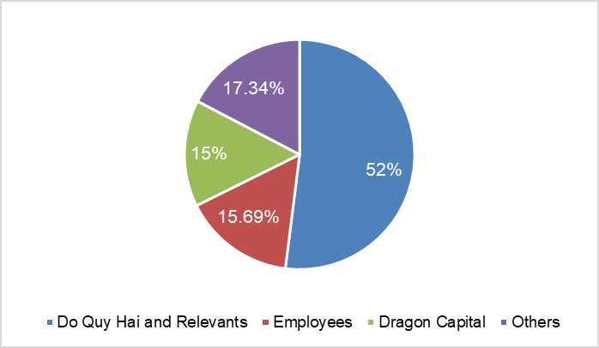  Investor relations activities  On October 12, 2018, HPX met with representatives of Phu Hung Securities JSC (PHS). At the meeting HPX answered questions and provided some details about the current financial situation of the company and the implementation of projects that Hai Phat is the investor. On the same day, HPX also met with representatives of Daewon Group to seek cooperation opportunities and become strategic partnership. In Q4 / 2018, HPX also had many meetings with large domestic and foreign financial institutions to discuss about cooperation opportunities such as Indovina Bank, Rong Viet Securities Company, Mirae Asset Securities Company and ASAM, AGCG investment fund, ... | CONTENT  1. Real estate market news  2. Hai Phat Invest business activities highlights  3. Business results in Q4/2018  4. Finished and on-going projects list  - Real estate market news  Regarding sales, according to statistics of Vietnam Real Estate Brokerage Association, there are about 27,595 products successfully traded in 2018, increase of 132.8% compared to 2017. The total product supply in the quarter 4/2018 in Hanoi market is 15,813 products, including 14,779 apartments and about 1,034 adjacent villas and townhouses. In particular, the proportion of mid-end apartments accounted for the highest proportion with 41.3%, followed by affordable apartments of 34.6% and high-end and luxury apartments of 24%.  On the price level, the average selling price on the primary market in the fourth quarter is about 1,304 USD / m2, decrease 2% compared to the same period last year. Trading results were also quite impressive when the transaction volume in this quarter increased by 4,669 transactions compared to the third quarter and increased by 3,429 transactions compared to the fourth quarter of 2017.  In 2019, mid-range products will continue to dominate the market due to a large supply, stable and a downward trend in price along with forecasts of economic growth and changes in income and consumption needs of people.  As one of the biggest market capitalization industries in the economy, real estate will continue to play a leading role in Vietnam's economy in the following year when all the supportive conditions for industry development will be satisfied such as young population, high economic growth rate, opportunities in 2019 and the following years are entirely within the capabilities of real estate businesses which having strong financial potential, high quality products and ability to mobilize the capital. But the comparison will be more difficult when more and more FDI enterprises are joining to Vietnam market.  Activities news  Hai Phat Investment JSC (Hai Phat Invest, HSX: HPX) celebrates an important milestone of 15 years of operation. On December 15, 2018, Hai Phat Invest celebrated the 15th anniversary of establishment at the Vietnam National Convention Center with the participation of nearly 1,000 guests including domestic and foreign employees, partners. Accordingly, HPX offers a message of aspiration to become a leading and prestigious real estate developer in Vietnam's real estate market. At of the end of 2018, Hai Phat Invest's development path has achieved many typical imprints, such as: Charter capital increased from 8 billion VND in 2003 to 1,725 ​​billion VND in 2018; Total assets reached 7,398 billion VND by the end of Q4/2018; Impressive growth in profit after tax from 2016 till now reached 93.57% in 2017 and approximately 40% by the end of 2018; Statistics of products brought to the market were 5,594 apartments, 1,309 adjacent villas, 503,113 m2 of construction floor area; won many awards such as Vietnam Top Brand 2016, top 10 Asia - Pacific brands in 2017, top 100 Vietnam Gold Star Awards 2018, Vietnam National Real Estate Award 2018 for The Vesta project of the best social housing, Top 3 best real estate trading floors in Vietnam, etc. The company also set goals that till 2023, HPX will become the leading company having big size and good capacity in real estate industry, captures trends and creates land fund with prime location and reasonable cost, thereby offering products with real value and impressive with the community.  On October 15, 2018, Hai Phat Investment Joint Stock Company announced to pay stock dividends at the rate of 15%, the final registration date is November 2, 2018, ex-right date is 1/11/2018; The Board of Directors approved the private issuance of corporate bonds and approved the plan of issuing private bonds in 2018 with a total expected value of VND 250 billions. On 11/15/2018, HPX announced the information of the Board of Directors approving the plan to issue shares to increase charter capital from equity in 2017 at a rate of 15.94%, equivalent to the number of shares is 27,496,497 shares. 27/12/2018, Hai Phat Investment announced information about the issuance of private corporate bonds and approved the plan of issuing private bonds in the fourth quarter of 2018 with a total expected value of VND 300 billions.  Source: Stoxplux

- Business result 2018
Items (billion VND) | 2018 | 2017 | %/2017 | 2018 PLAN | %/PLAN
Sales | 2,019.62 | 1,080.47 | 186.9% | 3,290 | 61.39%
Cost of goods sold | 1,525.78 | 797.25 | 191.38% | - | -
Gross profit | 493.85 | 283.22 | 174.37% | - | -
Profit from business activities | 579.57 | 412.23 | 86.11% | - | -
Other income | 19.02 | (9.34) | - | - | -
Profit before tax | 598.59 | 402.89 | 148.57% | 562 | 106.51%
Profit after tax | 452.31 | 325.17 | 139.10% | 450 | 100.51%
HPX’s Financial Statement
- Company projects
Order | Project | Size | Time | Invesment Capital  (Billion VND)
Completed Project
1 | Van Phu urban area, Ha Dong, Hanoi | Acreage: 5.0 ha | Quarter 1/2007 –  Quarter 4/2010 | 650
2 | Tan Tay Do urban area, Dan Phuong, Hanoi. | Acreage: 5.24 ha | Quarter 1/2010 –  Quarter 4/2014 | 1,590
3 | The Pride - complex of commercial services and apartments, An Hung new urban area, Ha Dong, Hanoi | Acreage: 2.9 ha | Quarter 2/2009 –  Quarter 3/2015 | 3,260
4 | Van Phuc 24h Commercial townhouse, Ha Dong, Hanoi. | Acreage: 7,192 m2 | Quarter 3/2016 –  Quarter 4/2017 | 710
Processing
5 | The Vesta, Ha Dong, Hanoi | Acreage: 45,093.3 m2 | Quarter 4/2015 –  Quarter 4/2018 | 1,757
6 | Phu Luong new urban area, Ha Dong, Hanoi. | Acreage: 3,576 ha | Quarter 1/2018 –  Quarter 3/2019 | 1,082
7 | HPC Landmark 105, Ha Dong, Hanoi | Acreage: 10,788.9 m2 | Quarter 4/2016 –  Quarter 3/2018 | 1,510
8 | Roman Plaza, Nam Tu Liem, Hanoi | Acreage: 35,893 m2 | Quarter 2/2016 –  Quarter 2/2019 | 2,705
9 | Bea Sky Tower, Hoang Mai, Hanoi | Acreage: 5,000 m2 | Quarter 3/2017 –  Quarter 4/2019 | 793.5
10 | Hanoi Homeland, Long Bien, Hanoi | Acreage: 17,101 m2 | Quarter 3/2017 –  Quarter 3/2019 | 1,418
11 | Thuan An Central Lake | Acreage: 17,542.4 m2 | Quarter 1/2018 –  Quarter 3/2019 | 458
Coming Deployment
12 | BT traffic lines project | 5 traffic lines in Ha Dong District and Hoai Duc District, 6.18 km. | Quarter 4/2018 –  Quarter 4/2020 | 1,960
13 | Phu Lam housing area | Acreage: 13.64 ha | 2019-2022 | 795
14 | Kien Hung tower and housing area | Acreage: 2.2 ha | 2019-2021 | 312
15 | Kiến Hưng urban functional area | Acreage: 7.4 ha | 2019-2022 | 838
16 | Bac Lam urban area | Acreage: 41.6 ha | 2019-2023 | 1,643
17 | Duong Noi housing area | Acreage: 2.6 ha | 2019-2021 | 199
18 | Ha Cau housing area | Acreage: 2.3 ha | 2019-2021 | 679
19 | BT South Ha Tay traffic line Project | Length: 41,500 km | Quarter 3/2020 | 3,795
20 | My Hung reciprocal project – urban area project | Acreage: 182 ha | 2019-2022 | 8,487
21 | West Nam An Khanh urban area | Acreage: 87 ha | 2020-2022 | 3,498
22 | Dong Quang high-tech eco-agricultural garden houses project | Acreage: 30 ha | 2019-2022 | 500
23 | An Binh 1 new urban area | Acreage: 164 ha | 2019-2022 | 4,891
24 | An Binh 2 new urban area | Acreage: 584 ha | 2019-2022 | 4,160
25 | Nam Bim Son urban area | Acreage: 129 | 2020-2022 | 1,898
26 | Renovation of old apartment buildings project at Nam Dinh City | Acreage: 6.2 ha
27 | TM1 Con Tan Lap, Nha Trang project | Acreage: 0.8 ha | 2019-2022 | 3,945
28 | Sunshine Hill Binh Thuan project | Acreage: 7.4 ha | 2019-2020 | 955
29 | Phu Hai luxury villas project | Acreage: 5 ha | 2019-2020 | 602
30 | Ham Tien tourist center, Mui Ne, Binh Thuan | Acreage: 198 ha | 2019-2024 | 5,834
31 | SEA Thuan Phuoc project | Acreage: 1.2 ha | 2019-2022 | 2,885
32 | Binh Minh Nha Trang project | Acreage: 54.2 ha | 2019-2021 | 3,717
33 | Nam Dinh tourism and industrial urban areas project | Acreage: 4.2 ha
34 | Bien Xanh, Vung Tau project | Acreage: 10.5 | 2020-2022
35 | Cai Khe, Can Tho project | Acreage: 2.34 | 2020-2023
36 | Yen Quang, Ninh Bình resort | Acreage: 350 ha | 2020-2023
37 | The Phoenix project | Acreage: 4.16 | 2019-2021
38 | Ray river, Vung Tau project | Acreage: 7.5 | 2020-2022
39 | Binh Anh, Tan An City new urban area | Acreage: 19 | 2020-2022
40 | Tay Nam, Ba Ria ecological urban area | Acreage: 1,800 | 2020-2021
Source: HPX

BALANCE SHEET
Quota | 31/12/2018 | 31/12/2017 | Increase/ Decrease (%) | CAGR  (2015-2018)  (%)
TOTAL ASSETS | 7,398.33 | 6,576.02 | 12.5% | 13.72%
Short - term assets | 3,049.97 | 2,598.89 | 17.4% | 4.89%
Cash & cash equivalent | 460.40 | 558.5 | -17.5% | 16.66%
Short-term investment | 0.00 | - | - | -
Other short-term receiveable | 1,349.07 | 1,269.91 | 6.2% | 38.97%
Inventories | 1,160.95 | 697.23 | 66.5% | -11.16%
Other short-term assets | 79.55 | 73.60 | 8.1% | 15.70%
Long-term assets | 4,348.36 | 3,977.13 | 9.3% | 22.93%
Long-term receiveable | 321.00 | 52.06 | 516.6% | -5.30%
Fixed assets | 270.82 | 727.97 | -62.8% | 90.09%
Long – term assets in progress | 2,259.01 | 2,220.60 | 1.7% | 35.98%
Long - term investment | 590.73 | 540.00 | 9.4% | -5.93%
Other long-term assets | 333.35 | 436.50 | -23.6% | 47.99%
TOTAL LIABILITIES &OWNER’S EQUITY | 7,398.33 | 6,576.02 | 12.5% | 13.72%
Liabilities | 4,839.72 | 4,487.33 | 7.9% | 9.54%
Short-term liabilities | 2,470.12 | 1,744.15 | 41.6% | 0.36%
Long-term liabilities | 2,369.61 | 2,743.18 | -13.6% | 26.48%
Owner’s equity | 2,558.60 | 2,088.69 | 22.5% | 24.56%
Source: Stoxplus, HPX consolidated financial statement
Because the projects of the company are being in the process of construction, completion and being transferred in the fourth quarter, so in asset and liability structure, three accounting items: receivables, inventories and long term uncompleted assets take the largest proportion, accounted for 18.23%, 15.69% and 30.53% respectively. Reciprocity for projects is loans (both short and long term) accounting for 65.40%.
Financial Ratios
Quota | UNIT | 31/12/2018 | 31/12/2017 | %Increase/Decrease
Solvency
Current ratio | Times | 1.23 | 1.49 | -17.45%
Quick ratio | Times | 0.73 | 1.05 | -33.03%
Capital structure
Debt/Total asset ratio | Times | 0.65 | 0.68 | -4.41%
Debt/Equity ratio | Times | 1.89 | 2.15 | -12.09%
Profitability
Gross profit margin | % | 24.45% | 26.21% | -6.71%
Profit from business activities/ Net sales | % | 28.70% | 38.15% | -24.77%
Gross profit | % | 22.40% | 30.10% | -25.58%
ROE | % | 19.47% | 15.57% | 25.05%
ROA | % | 6.47% | 4.94% | 30.97%
Source: Stoxplus, HPX Consolidated Financial Statement
HPX recorded net revenue in 2018 at 2,019.62 billion VND, of which revenue from real estate business was 1,401.15 billion VND (+ 13.72% YoY), revenue from service provision 3.65 billion VND, other operating revenue of VND 81.82 billion (+ 58.60% YoY).
Gross profit reached VND 493.85 billion (+ 74.46% YoY). Gross profit margin reached 24.45% (-6.71% YoY).
Profit before tax (PBT) reached 598.59 billion VND (+ 48.57% YoY). Profit after tax (EAT) of 452.32 billion VND (+ 39.10% YoY). Net profit / Average total asset ratio (ROA): 6.47% (+ 25.05% YoY) and Net Profit / Equity (ROE) ratio: 19.47% (+ 30.97% YoY).
Total assets (TA) as of December 31, 2018 reached 7,398.33 billion VND, an increase of 12.50% compared to the beginning of the year mainly due to short-term receivables, inventory and fixed assets. Long-term uncompleted assets: 2,259.01 billion VND, an increase of 1.73% compared to the beginning of the year mainly in Phu Lam social projects and Hai Phat Plaza project. Equity reached 2,558.60 billion VND, an increase of 22.50% compared to the beginning of the year, due to undistributed after-tax profit increased by 102.68% and contributed capital of owner increased 33.33%.
HPX's solvency ratios: Short-term payment ratio is 1.23 times (-17.45% YoY), Quick Ratio is 0.73 times (-33.03% YoY), though, HPX still maintain indicators of liquidity at safe limits and ensure solvency.
The Debt / Total Asset ratio and Debt / Equity ratio on December 31, 2018 were 0.65 times and 1.89, respectively, down 4.41% YoY and 12.09% YoY, respectively. Although there is a decrease compared to the beginning of the year, because HPX continues to invest in large projects and expand its network, HPX is maintaining reasonable capital structure indicators in allowable limits, within the limits of financial risk control and operational efficiency.
Compares to competitors
31/12/2018 | HPX | DIG | DXG | HDG | KDH | NLG | PDR | SCR | TDH | VPI
Price | 26,000 | 15,500 | 23,800 | 34,500 | 33,000 | 25,800 | 25,500 | 7,300 | 10,100 | 42,350
Book Value | 12,722 | 12,192 | 14,282 | 18,378 | 16,581 | 19,226 | 12,938 | 12,476 | 21,223 | 14,046
Market Capitalization | 5,200 | 4,128 | 8,507 | 3,508 | 12,918 | 6,457 | 7,113 | 2,531 | 873 | 6,640
P/E (Trailing) | 11.05 | 12.97 | 7.22 | 5.78 | 15.97 | 8.26 | 11.05 | 10.73 | 4.99 | 15.73
P/B (Trailing) | 1.97 | 1.34 | 1.70 | 2.01 | 1.88 | 1.40 | 2.06 | 0.60 | 0.50 | 2.95
Average trading value YTD (billion VND) | 12.48 | 46.43 | 99.66 | 8.05 | 13.12 | 16.22 | 40.44 | 46.68 | 8.84 | 11.65
Source: Stoxplus, collected by HSC

Contact information
1. Mrs. Nguyen Thanh Hieu – Director, Investor Relations & Public Relations (HPX)
Email: hieu.nt@haiphat.vn – Mobile: 0989257495
2. Mrs. Nguyen Khanh Phương – Investor Relations Deputy Manager (HPX)
Email: phuong.nk@haiphat.vn – Mobile: 0917844488
3. Bui Anh Dung – Investor Relations executive (HPX)
Email: dung.ba@haiphat.vn – Mobile: 0979258802
4. Department of Investor Relations, Investors and Communications (HPX)
Email: ir@haiphat.vn

The judgments in The Report are analyzed based on HPX owned information and considered to be acceptable suitability under current conditions without any price sensitivity announced. The Report does not constitute a “BUY” or “SELL” recommendation. HPX is not responsible for any loss due to usage of The Report for investment purpose. The Report is owned by HPX, any copying, reproduction, issuance or re-distribution for any purposes are prohibited without HPX agreement.

