PGB: Board Resolution
On December 27, 2023, Petrolimex Group Commercial Joint Stock Bank announced Resolution No. 161/2023/NQ-HDQT on changing the brand identity/brand of PG Bank as follows:
‎‎Article 1. Approve changing the brand identity/brand of PG Bank as follows:
- Logo with the trade name of the Bank (Vietnamese)
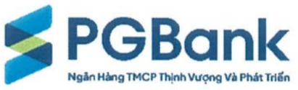
- Icon part: consists of a three-segmented polyline. The top and bottom segments are azure, the middle segment is navy blue and is obscured in the middle by a green stripe.
- Text part: divided into two lines written next to the icon part and in navy blue, which are the words "PGBank" and "Ngân Hàng TMCP Thịnh Vượng Và Phát Triển" (In which "TMCP" is the abbreviation for the word "Thương mại Cổ phần").
- Color: Azure, navy blue, green
- Logo with trade name of the Bank (English)
- Icon part: consists of a three-segmented polyline. The top and bottom segments are azure, the middle segment is navy blue and is obscured in the middle by a green stripe.
- Text part: divided into two stylized lines written in navy blue, which are "PGBank" and "PROSPERITY AND GROWTH COMMERCIAL JOINT STOCK BANK".
- Color: Azure, navy blue, green
- Main logo
- Icon part: consists of a three-segmented polyline. The top and bottom segments are azure, the middle segment is navy blue and is obscured in the middle by a green stripe.
- Text part: PG BANK (abbreviation of the bank's name: Prosperity and Growth Commercial Joint Stock Bank).
- Color: Azure, navy blue, green
- Logo with Vietnamese slogan
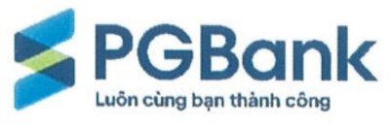
- Icon part: consists of a three-segmented polyline. The top and bottom segments are azure, the middle segment is navy blue and is obscured in the middle by a green stripe.
- Text part: divided into two navy blue lines, which are the words "PGBank" and the words "Luôn cùng bạn thành công"
- Color: Azure, navy blue, green
- Logo with English slogan
- Icon part: consists of a three-segmented polyline. The top and bottom segments are azure, the middle segment is navy blue and is obscured in the middle by a green stripe.
- Text part: divided into two navy blue lines, which are the words "PGBank" and the words "Success Together"
- Color: Azure, navy blue, green.
‎‎Article 2. Assign the General Manager, based on the actual situation and demands of PG Bank, to direct and implement the preparation of dossiers, and complete procedures related to changing the brand identity/brand of PG Bank, including: (i) Carry out legal procedures to request approval from the competent authorities for brand change; (ii) Proactively decide to edit details at the request of the State Management Agency and sign related documents and materials; (iii) Implement and decide on other contents related to changing brand/brand identity such as communication work (internal, press releases, customer partners...), disclose information as per the provisions of law and internal regulations of PG Bank.
‎‎Article 3. This Resolution takes effect from the date of its signing. Members of the Board of Directors, the General Manager, and relevant units, individuals are responsible for implementing this Resolution.

