XHC: Annual Corporate Governance Report 2023
On January 23, 2024, XuanHoa VietNam JSC announced Report No. 03/BC-XHC on corporate governance situation in 2023, as follows:
- Name of company: XuanHoa VietNam JSC
- Head office address: Nguyen Van Linh Street Phuc Thang Ward, Phuc Yen City, Vinh Phuc Province
- Tel: 02113.863.244 Email: xuanhoa@xuanhoa.vn
- Charter capital: VND 210,965,000,000
- Securities code: XHC
- Corporate governance model:
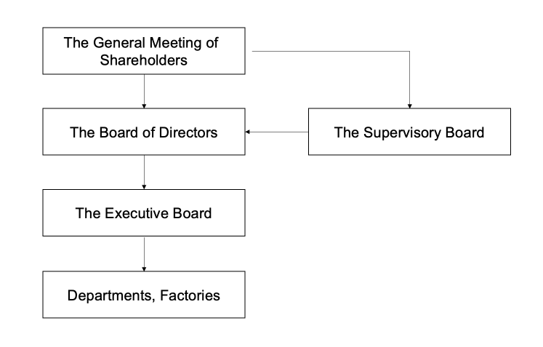
- Internal audit execution: Not implemented.
- Activities of the General Meeting:
Information about the meetings and General Mandates/Decisions of the General Meeting (including General Mandates approved by collecting shareholders' ballots):
No. | General Mandate/Decision of the General Meeting | Date | Contents
1 | 01/XH-NQ-DHDCD | June 28, 2023 | Annual General Mandate 2023
- Board of Directors (annual report 2023)
- Information about members of the Board of Directors:
No. | Member of the Board of Directors | Position | Date of appointment/dismissal as member/independent member of the Board of Directors
 |  |  | Appointment date: | Dismissal date
1 | Mr. Nguyen Viet Anh | Chair of the Board of Directors | April 30, 2022
2 | Mr. Nguyen Hoang Hai | Member of the Board of Directors | April 30, 2022
3 | Mr. Khuc Van Quang | Member of the Board of Directors | April 30, 2022
4 | Mr. Nguyen Anh Tuan | Member of the Board of Directors | November 08, 2022
5 | Mr. Nguyen Tien Hai | Member of the Board of Directors | November 08, 2022
- Board Resolutions/Board Decisions (Report of 2023):
No. | Board Resolution/Board Decision | Date | Contents
1 | No. 01/NQ-HDQT | January 18, 2023 | Dismiss Ms. Dang Thanh Thuy from the position of Deputy Managing Director of XuanHoa VietNam Joint Stock Company
2 | No. 02/QD-HDQT | February 18, 2023 | Appoint Mr. Khuc Van Quang as Deputy Managing Director of XuanHoa VietNam Joint Stock Company
3 | No. 03/QD-HDQT | February 18, 2023 | Appoint Mr. Nguyen Hoang Hai as Deputy Managing Director of XuanHoa VietNam Joint Stock Company
4 | No. 04/QD-HDQT | February 18, 2023 | Appoint Mr. Khuc Manh Viet as Deputy Managing Director of XuanHoa VietNam Joint Stock Company
5 | No. 05/QD-HDQT | February 18, 2023 | Decision to contribute capital to establish Demy Furniture Joint Stock Company
6 | No. 06/QD-HDQT | February 18, 2023 | Decision to contribute capital to establish Xuan Hoa Elevator Joint Stock Company
7 | No. 07/QD-HDQT | February 18, 2023 | Decision to contribute capital to establish Xuan Hoa Home Company Limited
8 | No. 08/QD-HDQT | February 18, 2023 | Decision to contribute capital to establish Xuan Hoa Power Company Limited
9 | No. 09/QD-HDQT | February 18, 2023 | Approve the policy of contributing capital to establish XHT Company .
10 | No. 10 /NQ-HDQT | March 07, 2023 | Approve the plan on convening the Annual General Meeting 2023
11 | No. 11/NQ-HDQT | September 08, 2023 | Approve the production and business plan of the Company in Q4/2023
12 | No. 12 /NQ-HDQT | December 28, 2023 | Approve the plan to transfer shares at Xuan Hoa Home Company Limited
- Supervisory Board (Report of 2023):
- Information about the members of the Supervisory Board
No. | Member of the Supervisory Board | Position | Date of appointment as member of the Supervisory Board. | Qualification
1 | Mr. Truong Hong Phong | Chief of the Supervisory Board | April 30, 2022 | Bachelor in Accounting
2 | Ms. Pham Thi Tung Anh | Member of the Supervisory Board | November 08, 2022 | Bachelor in Economics
3 | Ms. Tran Thi Thu Hang | Member of the Supervisory Board | November 08, 2022 | Bachelor in Economics
- Executive Board:
No. | Member of the Executive Board | Date of birth | Qualification | Date of appointment/dismissal as member of the Executive Board
1 | Mr. Nguyen Anh Tuan | December 28, 1979 | Master of Business Administration | Appointed on October 07, 2022
2 | Ms. Nguyen Thi Hieu | October 27, 1976 | Bachelor in Economics | Appointed on July 26, 2022
3 | Mr. Khuc Van Quang | February 12, 1976 | Master of Business Administration | Appointed on February 18, 2023
4 | Mr. Nguyen Hoang Hai | October 07, 1980 | Manufacturing Mechanical Engineer | Appointed on February 18, 2023
5 | Mr. Khuc Manh Viet | February 17, 1980 | Bachelor in Business Administration | Appointed on February 18, 2023
6 | Mr. Le Van Giang | January 25, 1984 | Master of Business & Management | Appointed on August 03, 2023
- Chief Accountant
No. | Full name | Date of birth | Qualification | Date of appointment / dismissal
1 | Ms. Nguyen Thi Hieu | October 27, 1976 | Bachelor in Economics | Appointed on July 26, 2022
- Training on corporate governance
- List of related persons of the public company and transactions between the related persons of the Company and the Company itself
- Transactions between the Company and related persons of the Company; or between the Company and majority shareholders, PDMR, or persons related to the PDMR: None.
- Transactions between the Company’s PDMR, related persons of PDMR and subsidiaries, companies controlled by the Company: None.
- Transactions between the Company and other entities/
- Transactions between the Company and the companies where members of the Board of Directors, members of the Supervisory Board, Executive Manager (Managing Director) and other managers who have been founding members or members of the Board of Directors or Executive Manager (Managing Director) for the past three (03) years (at the date of reporting)
- Toyota Boshoku Inoac Vietnam Co., Ltd. provides parts and components of car seats, car floor mats.
- Xuan Hoa Elevator Joint Stock Company provides elevator products
- Demy Furniture Joint Stock Company provides office furniture products.
- Xuan Hoa Power Joint Stock Company provides electrical equipment products
  - Transactions between the Company and companies executed by the related people of members of the Board of Directors, members of the Supervisory Board, Executive Manager (Managing Director) and other managers who are members of the Board of Directors and Executive Manager (Managing Director). None.
  - Other transactions of the Company (if any) which can bring about material or non-material benefits to members of the Board of Directors, members of the Supervisory Board, Executive Manager (Managing Director) and other managers: None.
- Share transactions of PDMR and related persons of PDMR (in 2023):
- Transaction of PDMR and related persons related to the Company’s shares:
No. | Transaction conductor | Relations with PMDR | Number of shares owned at the beginning of the period |  | Number of shares owned at the end of the period |  | Reason for increase/decrease (purchase, sell, or award,...)
 |  |  | Number of shares: | Rate | Number of shares | Rate
1 | Nguyen Hoang Hai | PDMR/related persons of PDMR | 0 | 0% | 2,390,282 | 11.3% | Buy shares
2 | Bao Viet Fund Management Limited Company. | Related person | 3,940,282 | 18.69% | 2,400,000 | 11.38% | Sell shares
3 | Dao Duc Chinh | Related person | 2,646,800 | 12.55% | 96.800 | 0.46% | Sell shares
- Other significant issues:

