SKV: Annual Corporate Governance 2023
On January 26, 2024, Khanh Hoa Salanganes Nest Soft Drink JSC announced Report No. 12/2024/BC-SKV on the corporate governance in 2023 as follows:
The Company’s name: Khanh Hoa Salanganes Nest Soft Drink JSC
Head office National Highway 1A, Suoi Hiep Commune, Dien Khanh District, Khanh Hoa Province
Tel: (0258) 3745601 Fax: 0258 3745605
Email: sanestdk@yensaokhanhhoasanest.com.vn
sanvinest@sanvinest.com.vn
Charter capital: VND 230,000,000,000
Securities code: SKV
Logo of the Company:
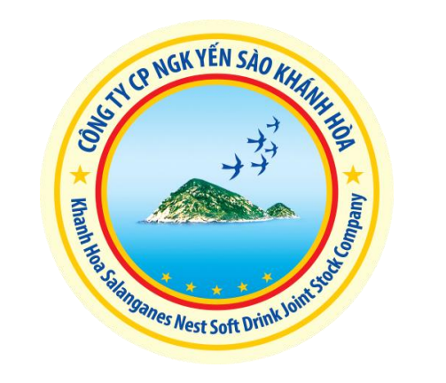
Corporate governance model:
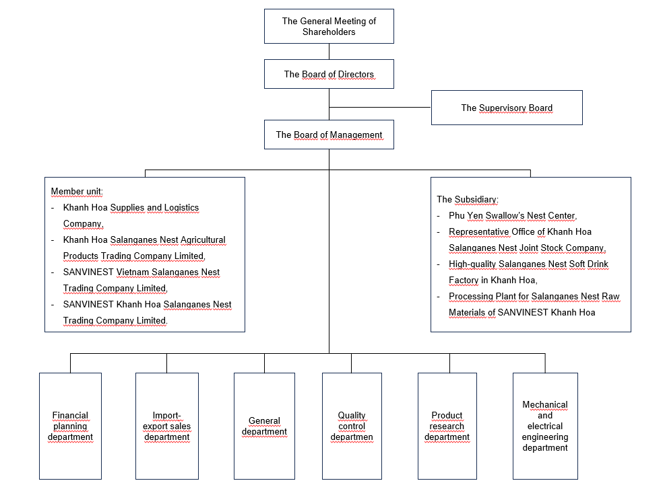
Internal audit execution: The Company always fully performs audit activities in accordance with the provisions of law.
- Activities of the General Meeting of Shareholders:
No. | General Mandate No. | Date | Content
1 | 04/2023/NQ-DHDCD-SKV | April 10, 2023 | Annual General Mandate 2023
- THE BOARD OF DIRECTORS (ANNUAL REPORT 2023):
- Information about members of the Board of Directors:
No. | Member of the Board of Directors | Position | Date of appointment/dismissal as member of the Board of Directors
 |  |  | Appointment date | Dismissal date
1 | Ms. Trinh Thi Hong Van | Chair of the Board of Directors | Re-appointed on June 04, 2021
2 | Mr. Nguyen Khoa Bao | Member of the Board of Directors | Re-appointed on June 04, 2021
3 | Ms. Vuong Pham Phuong Thanh | Member of the Board of Directors | Re-appointed on June 04, 2021
4 | Mr. Huynh Duc Trong | Member of the Board of Directors | Newly appointed on June 04, 2021
5 | Mr. Le Hong Thuan | Member of the Board of Directors | Re-appointed on June 04, 2021
- Board Resolutions, Board Decisions
No. | Board Resolution No. | Date | Content
1 | 01 /NQ-HDQT | February 06, 2023 | Approve the transaction and contracts between the Company and related parties.
2 | 02 /NQ-HDQT | February 20, 2023 | The record list of shareholders attending the Annual General Meeting of Shareholders 2022:
3 | 03 /NQ-HDQT | April 06, 2023 | Results on the production and business activities in Q1/2023 and the execution plan for Q2/2023;
4 | 04/2023/NQ-DHDCD-SKV | April 10, 2023 | The Annual General Meeting of Shareholders of 2022
5 | 05 /NQ-HDQT | May 24, 2023 | Record the list of shareholders to dividends payment 2022.
6 | 06 /NQ-HDQT | July 03, 2023 | Report on production and business activities in the first 6 months of 2023 and the Plan for Q3/2023;
7 | 07/NQ-HDQT | October 04, 2023 | Results on the production and business activities in Q3/2023 and the production and business plan for Q4/2023;
8 | 08/NQ-HDQT | October 24, 2023 | Title conversion at Khanh Hoa Salanganes Nest Joint Stock Company and issuance of Articles of Association, Internal Regulations on corporate governance, and the Operating Regulations of the Board of Management (First Amendment).
9 | 09/NQ-HDQT | December 07, 2023 | Approve the capital loan at  Joint Stock Commercial Bank for Foreign Trade of Vietnam
10 | 10/NQ-HDQT | December 07, 2023 | Approve the capital loan at Vietnam Bank for Industry and Trade Securities
11 | 11/NQ-HDQT | December 07, 2023 | Approve to borrow capital at Military Commercial Joint Stock Bank
12 | 12/NQ-HDQT | December 07, 2023 | Results on the production and business activities in November 2023 and the production and business plan for December 2023;
- The Supervisory Board (Annual Report of 2023)
- Information about members of the Supervisory Board:
No. | Member | Position | Date of appointment/dismissal as member of the Supervisory Board | Professional Qualification
1 | Ms. Vu Tran Nguyen Minh | Chief of the Supervisory Board | Re-appointed on June 04, 2021 | Bachelor of Finance and Banking, Master of Business Administration
2 | Mr. Ho Hai | Member | Re-appointed on June 04, 2021 | Bachelor of Business Accounting
3 | Mr. Pham Duy Hung | Member of the Supervisory Board | Re-appointed on June 04, 2021 | Bachelor of Finance and Banking
- The Board of Management (Report of 2023):
No. | Member of the Board of Management | Position | Date of birth | Professional Qualification | Date of appointment/dismissal as member of the Board of Management
1 | Mr. Nguyen Khoa Bao | General Manager | April 06, 1972 | Bachelor of Economics | Re-appointed on June 11, 2021
2 | Mr. Dang Minh Thich | Deputy General Manager | January 10, 1965 | Food Chemical Engineer | Re-appointed on December 02, 2022
3 | Ms. Phan Thi Giang | Deputy General Manager | September 13, 1976 | Food Technologist, Bachelor of Accounting | Re-appointed on July 22, 2020
4 | Mr. Pham Quoc Hung | Deputy General Manager | May 28, 1976 | Mechanical Engineer | Re-appointed on November 17, 2022
5 | Mr. Huynh Duc Trong | Deputy General Manager | November 27, 1979 | Bachelor of Economics | Appoint on January 02, 2021
(*) According to the policy approved in the Resolution of the Annual General Meeting of Shareholders for the fiscal year 2022 dated April 10, 2023, Board Resolution No. 08/NQ-HDQT dated October 24, 2023 of the Company approved the title transfer. “Manager”, “Deputy Manager” become “General Manager”, “Deputy General Manager”.
- The Chief Accountant (Report of 2023)
Full name | Date of birth | Professional Qualification | Date of appointment/ dismissal
Ms. Pham Thi Lanh | January 20, 1975 | Bachelor of Corporate Accounting | Re-appointed on December 02, 2022
- Training on corporate governance
- List of affiliated persons of the public company (Annual Report of 2023) and transactions between the affiliated persons of the Company with the Company itself
- Transactions between the Company and affiliated persons of the Company, or between the Company and major shareholders, PDMR, or affiliated persons of PDMR:
No. | Name of organization/individual | Relations with the Company | NSH* No., date of issue, place of issue | Head office/Contact address | Time of transaction with the Company | General Mandate/Decision of the General Meeting of Shareholder No. or Board Resolution/Board Decision No. (including date of promulgation, if any) | Content, quantity, total value of transaction | Note
1 | Khanh Hoa State-owned Salanganes Nest One Member Company Limited | Holding Company, owning 51% of charter capital. | Business Registration Certificate No. 4200338918 | No. 248 Thong Nhat Street, Nha Trang City, Khanh Hoa Province. | 2023 |  | - Khanh Hoa Salanganes Nest Soft Drink JSC sell goods and provided services:  1145063680260  VND  - Khanh Hoa Salanganes Nest Soft Drink JSC purchased products and services  VND 28,849,205,956  Khanh Hoa Salanganes Nest Soft Drink JSC pays dividends: VND 34,955,400,000
2 | Khanh Hoa Material Supply One Member Company Limited | Subsidiary, owning 100% of charter capital. | Business Registration Certificate 4201767187 | Vinh Cat Village, Suoi Hiep Commune, Dien Khanh District, Khanh Hoa Province | 2023 |  | - Khanh Hoa Salanganes Nest Soft Drink JSC sold goods and finished products: VND 1,225,498,146  - Khanh Hoa Salanganes Nest Soft Drink JSC purchased materials and goods: VND 150,590,311,401  - Khanh Hoa Salanganes Nest Soft Drink JSC used services: VND 2,143,589,072  - Loan from Khanh Hoa Salanganes Nest Soft Drink JSC: VND 47,000,000,000  - Loan principle recovered by Khanh Hoa Salanganes Nest Soft Drink JSC: VND 80,000,000,000  - Loan interest collected by Khanh Hoa Salanganes Nest Soft Drink JSC: VND 3,214,547,947  - Distributed profits: VND 8,389,980,269
3 | Công ty TNHH MTV Nhà máy Nước giải khát cao cấp Yến sào Khánh Hòa (tentatively translated as “Khanh Hoa Salanganes Nest Premium Beverage Factory One Member Company Limited” | Subsidiary, owning 100% of charter capital. | Business Registration Certificate 4201770743 | Lot NM5, NM6, Road I, Song Cau Industrial Cluster, Song Cau Commune, Khanh Vinh District, Khanh Hoa Province | 2023 |  | License fee submitted by Khanh Hoa Salanganes Nest Soft Drink JSC: VND 3,000,000
4 | Sanvinest Viet Nam Salanganes Nest One Member Ltd Company | Subsidiary, owning 100% of charter capital. | Business Registration Certificate 4201815338 | National Highway 1A, Cu Thanh Village, Suôi Hiep Commune, Dien Khanh District, Khanh Hoa Province | 2023 |  | License fee submitted by Khanh Hoa Salanganes Nest Soft Drink JSC: VND 3,000,000
5 | Sanvinest Khanh Hoa Salanganes One Member Ltd Company | Subsidiary, owning 100% of charter capital. | Business Registration Certificate 4201815419 | National Highway 1A, Cu Thanh Village, Suôi Hiep Commune, Dien Khanh District, Khanh Hoa Province | 2023 |  | License fee submitted by Khanh Hoa Salanganes Nest Soft Drink JSC: VND 3,000,000
6 | FISHSAN Aquaculture One Member Limited Company | The company with 100% of charter capital owned by Khanh Hoa State-owned Salanganes Nest One Member Company Limited | Business Registration Certificate 4201766793 | No. 10 Yersin Street, Van Thanh Ward, Nha Trang City, Khanh Hoa Province | 2023 |  | Khanh Hoa Salanganes Nest Soft Drink JSC sold goods and provided services: VND 1,324,231,800
7 | Công ty TNHH MTV Quảng bá sản phẩm và Nhà hàng Yến sào Khánh Hòa (tentatively translated as “Khanh Hoa Sanest Restaurant And Products Promoting One Member Co., Ltd”) | The company with 100% of charter capital owned by Khanh Hoa State-owned Salanganes Nest One Member Company Limited | Business Registration Certificate 4201766786 | No. 04 Pham Van Dong Street, Vinh Tho Ward, Nha Trang City, Khanh Hoa Province | 2023 |  | - Khanh Hoa Salanganes Nest Soft Drink JSC sold goods and provided services: VND 8,923,366,685  - Khanh Hoa Salanganes Nest Soft Drink JSC purchased products and services VND 322,670,034
8 | Sanest Tourist Travel One Member Limited Liability Company | The company with 100% of charter capital owned by Khanh Hoa State-owned Salanganes Nest One Member Company Limited | Business Registration Certificate 4201675948 | No. 89 Thong Nhat Street, Van Thang Ward, Nha Trang City, Khanh Hoa Province | 2023 |  | - Khanh Hoa Salanganes Nest Soft Drink JSC sold goods and provided services: VND 4,555,423,300  - Goods sales and service provision VND 2,892,496,564
9 | Công ty TNHH MTV Dịch vụ Tuyến Bắc Nam (tentatively translated as “North - South Route Service One Member Co., Ltd”) | The company with 100% of charter capital owned by Khanh Hoa State-owned Salanganes Nest One Member Company Limited | Business Registration Certificate 4201766761 | National Highway 1A, My Thanh Village, Cam Thinh Dong Commune, Cam Ranh City, Khanh Hoa Province | 2023 |  | - Khanh Hoa Salanganes Nest Soft Drink JSC purchased fuel: VND 16,589,755,242  - Khanh Hoa Salanganes Nest Soft Drink JSC sold goods and provided services: VND 1,120,000
10 | Khanh Hoa Sanest Soft Drink Joint Stock Company | The company with 51.06% of charter capital owned by Khanh Hoa State-owned Salanganes Nest One Member Company Limited | Business Registration Certificate 4201675916 | National Highway 1A, My Thanh Village, Cam Thinh Dong Commune, Cam Ranh City, Khanh Hoa Province | 2023 |  | - Khanh Hoa Salanganes Nest Soft Drink JSC sold goods and provided services: VND 106,998,966,235  - Khanh Hoa Salanganes Nest Soft Drink JSC purchased raw materials and goods: VND 106,049,336,825
11 | Sanest Khanh Hoa One Member Company Limited | The company with 100% of charter capital owned by NGK Sanest Khanh Hoa Joint Stock Company | Business Registration Certificate 4201853950 | 9D Le Thanh Ton, Loc Tho Ward, Nha Trang City, Khanh Hoa Province | 2023 |  | - Khanh Hoa Salanganes Nest Soft Drink JSC sold goods and provided services: VND 38,334,285,191  - Khanh Hoa Salanganes Nest Soft Drink JSC purchased products and services VND 32,152,000
12 | Sanna Khanh Hoa Beverage Joint Stock Company | The company with 51% of charter capital owned by Khanh Hoa State-owned Salanganes Nest One Member Company Limited | Business Registration Certificate 4201675930 | National Highway 1A, My Thanh Village, Cam Thinh Dong Commune, Cam Ranh City, Khanh Hoa Province | 2023 |  | Khanh Hoa Salanganes Nest Soft Drink JSC purchase goods  Or: VND 1,625,779,355
13 | Khanh Hoa Sanest Restaurant One Member Limited Company | The company with 100% of charter capital owned by Khanh Hoa State-owned Salanganes Nest One Member Company Limited | Business Registration Certificate 4201766779 | Ground floor and second floor, No. 34 Le Thanh Phuong Street, Phuong Sai Ward, Nha Trang City, Khanh Hoa Province | 2023 |  | - Khanh Hoa Salanganes Nest Soft Drink JSC sold goods and provided services: VND 3,916,828,200  - Khanh Hoa Salanganes Nest Soft Drink JSC purchased products and services VND 1,465,908,273
14 | Khanh Hoa Lam Dong Salanganes Nest Restaurant and Tourism Services Company Limited | The company with 100% of charter capital owned by Khanh Hoa State-owned Salanganes Nest One Member Company Limited | Business Registration Certificate 5801357762 | No. 88 Phu Dong Thien Vuong Street, Ward 8, Da Lat City, Lam Dong Province | 2023 |  | Khanh Hoa Salanganes Nest Soft Drink JSC sold goods and provided services: VND 6,720,000
- Transactions between Company’s PDMR, affiliated persons of PDMR and subsidiaries, companies controlled by the Company
None
- Transactions between the Company and other entities/
  - Transactions between the Company and the companies in which members of the Board of Directors, members of the Supervisory Board, the Executive Manager have been being founding members or members of the Board of Directors, the Executive Manager for the past three (03) years (calculated at the time of reporting):
Presented in category 2: Transactions between the Company and affiliated persons of the Company; or between the Company and major shareholders, PDMR, or affiliated persons of PDMR.
  - Transactions between the Company and companies where affiliated persons of members of the Board of Directors, members of the Supervisory Board, the Manager and other managers are members of the Board of Directors, the Executive Manager:
None
  - Other transactions of the Company (if any) that can bring about material or non-material benefits to the members of the Board of Directors, the members of the Supervisory Board, Executive Manager and other managers:
None
- SHARE TRANSACTIONS OF PDMR AND AFFILIATED PERSONS OF PDMR (ANNUAL REPORT 2023)
- Transaction of PDMR and affiliated persons related to the Company’s shares:
No. | Transaction conductor | Relations with PMDR | Number of shares owned at the beginning of the period |  | Number of shares owned at the end of the period |  | Reasons for increase or decrease (buy, sell, convert, bonus, etc.)
 |  |  | Number of shares | Rate | Number of shares | Rate
1 | Nha Trang Trade Tourism Joint Stock Company | Company related to the member of the Board of Directors of Khanh Hoa Salanganes Nest Soft Drink JSC | 219,183 | 0.95% | 176,183 | 0.77% | Reduce ownership rate
- OTHER SIGNIFICANT ISSUES:

