TTB: Board Resolution
On July 9, 2024, TTBGroup Joint Stock Company announced Resolution No. 04/NQ-HDQT as follows:
Article 1: Approve of changing the seal sample of TTBGROUP Joint Stock Company, specifically as follows:
- Form and content of the seal sample:
Former seal sample | New seal sample
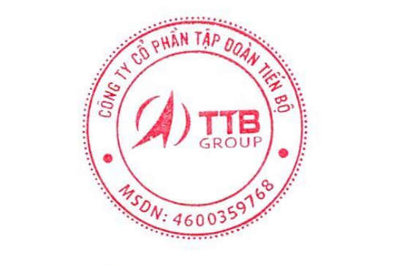 | 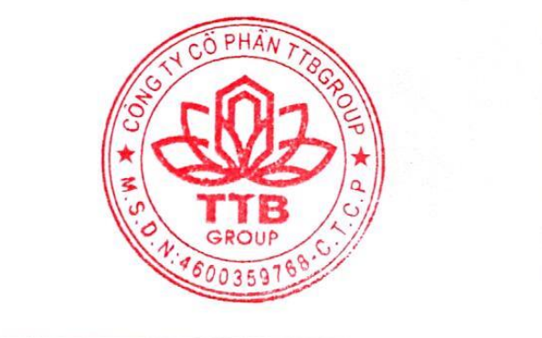
- Expiration date of the old seal sample is July 8, 2024.
- Effective date of the new seal sample is from July 9, 2024.
Article 2: Assign the General Manager of the Company to manage and use the seal according to the provisions of law.
Article 3: This Resolution takes effect from the date of its signing. Members of the Board of Directors, the Board of Managers and related departments are responsible for implementing this Resolution./.

