LPB123016: Board Resolution on changing the seal sample
On July 17, 2024, LienViet Post Joint Stock Commercial Bank announced Resolution No. 2211/2024/NQ-HDQT on changing the seal sample of LienViet Post Joint Stock Commercial Bank as follows:
‎‎Article 1. Change the LienViet Post Joint Stock Commercial Bank seal sample of Fortune Vietnam Joint Stock Commercial Bank, specifically:
- Name: Fortune Vietnam Joint Stock Commercial Bank.
- Business code: 6300048638.
- Address: LPB Tower, No. 210 Tran Quang Khai Street, Trang Tien Ward, Hoan Kiem District, Hanoi City
- The seal sample:
Former seal sample | New seal sample
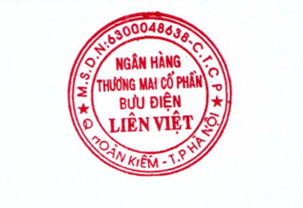 | 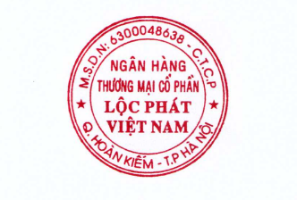
‎‎Article 2. Number of seal samples:
+ Number of seal samples before changing: 02 seals.
+ Number of seal samples after changing: 03 seals.
‎‎Article 3. Effective time of the seal: From July 17, 2024.
‎‎Article 4. Assign the Office to be responsible for preserving, managing, and using LienViet Post Joint Stock Commercial Bank’s seal in accordance with provisions of law and LienViet Post Joint Stock Commercial Bank.
‎‎Article 5. This Resolution takes effect from the date of its signing. The General Manager, Office, relevant units, and individuals are responsible for implementing in accordance with the provisions of law and LienViet Post Joint Stock Commercial Bank.

